

**A Report on**

**“Climate Analytics”**

**By**

|  |  |
| --- | --- |
| Shiny S Mathew | Rahul Reddy |
| Vinay K P | Boddu Poojitha |
| Neha A | Saptashwa Banerjee |
| Suryasundar Bose | Mukesh Nandy |
| C Nagababu |  |

**Under the guidance of**

**Mr. Arun Shankar - Delivery Manager, EY**

**Mr. Gaurav Kumar - Manager, EY**

**Mr. V Kiran - Trainer, Mazenet**

**CONTENTS**

1. **Acknowledgment**

1. **Abstract**

1. **Introduction**

**3.1 Objectives**

**3.2 Technology used**

**3.3 Overview of the Project**

1. **Implementation**

**4.1. Prerequisite software/packages**

**4.2. Flowcharts**

1. **Conclusion and future scope.**

**5.1. Conclusion**

**5.2. Limitations and challenges**

**5.3 Future scope**

1. **Output and screenshots**
2. **References**

**ACKNOWLEDGEMENT**

We would like to express our gratitude and appreciation to all those who encouraged and guided us in completion of this project.

We would like to extend our special thanks to our SMEs from EY, Mr Arun Shankar (Delivery Manager, EY), Mr. Gaurav Kumar(Manager, EY) and Mr. V Kiran (Trainer, Mazenet Solutions) for their encouragement, constructive suggestions and their technical assistance with respect to the successful completion of the project.

We would also like to acknowledge with much appreciation the crucial role of the Ernst & Young Mentors who gave us the required tools and technologies to develop our working model.

**ABSTRACT**

The project aims to provide a visual dashboard for climate analytics that can provide information about the Near real-time weather condition, for current and next 5-7 days, temperature increase Year-Over-Year and impact of harmful radiation.

**INTRODUCTION**

**1.1 Objective:**

The project aims to provide a visual dashboard for climate analytics that can give information about the Near real-time weather information for current and next 5-7 days, temperature increase Year-Over-Year and impact of harmful radiation. Climate science is a big data domain that is experiencing unprecedented growth. In our efforts to address the big data challenges of climate science, we are moving toward a notion of Climate Analytics, it combines high-performance computing and data-proximal analytics with scalable data management, cloud computing virtualization, the notion of adaptive analytics, and a domain-harmonized API to improve the accessibility and usability of large collections of climate data.

**1.2 Technology Used:**

(1) AZURE CLOUD COMPUTING SERVICE:

* We have three major cloud computing environments in the market such as Amazon Web Services (AWS), Google Cloud Platform (GCP) and Microsoft Azure out of which we have chosen Microsoft Azure because it gives us a user-friendly environment and we found it very much simple to step into the cloud computing world.
* At its core, Azure is **a public cloud computing platform**—with solutions including Infrastructure as a Service (IaaS), Platform as a Service (PaaS), and Software as a Service (SaaS) that can be used for services such as analytics, virtual computing, storage, networking, and much more.

(2) DATA BRICKS, DATA LAKE (TOOLS):

* **Databricks** is the implementation of Apache Spark on Azure. With fully managed Spark clusters, it is used to process large workloads of data and helps in data engineering, data exploring and visualizing data using big data.
* **Azure** **Data Lake** is a cloud platform designed to support big data analytics. It provides unlimited storage for structured, semi-structured or unstructured data. It can be used to store any type of data of any size

(3) POWER BI(VISUALIZATION)

* **Power BI** is a collection of software services, apps, and connectors that work together to unify data from many sources to create interactive, immersive dashboards and reports that provide actionable insights and drive business results.
* Data may be an Excel spreadsheet, or a collection of cloud-based and on-premises hybrid data warehouses. Power BI lets you easily connect to your data sources, visualize and discover what's important, and share that with anyone or everyone you want.
* There are two major visualization tools in the market such as Tableau and Power BI, we have chosen power BI because it has multiple visual as well as analytic tools than tableau

**1.3 Overview of the project:**

In this project we have used API and historical data to analyse the real time as well as historic weather conditions, impact of radiation and temperature increase year over year.

Firstly, to store the historical data we have used the data lake storage in Microsoft Azure. Later we cleaned the data using Data Bricks.

1. We have used Application programming Interface(API) to predict real time weather conditions for next one week using current weather data.
2. To predict year on year temperature we initialise the data using Data Bricks and connect it to Power BI for visualization purposes. There we have visualized the temperature difference of each state on a YoY basis. Along with temperature we have analysed different relations of temperature with pressure, humidity and precipitation.
3. To analyse the impact of radiation on our environment and life we have again used Power BI to visualize the impact. We have used multiple Power BI visualization techniques such as play axis, scroller, heat maps, etc.

Finally, once all the three condition statements are satisfied we merged it all together and connected it to Power BI for visualization.

**Implementation**

**2.1 Pre-requisite software:**

(1) Azure Cloud Computing Service (Environment)

(2) Data Bricks, Data Lake (Tools)

(3) Power BI(Visualization)

(4) Historical and real time (API) data of Temperature and Radiation along with other weather related categories.

**2.2 packages:**

(1) Pandas

(2) Datetime

(3) Request

**2.3 Flowchart:**

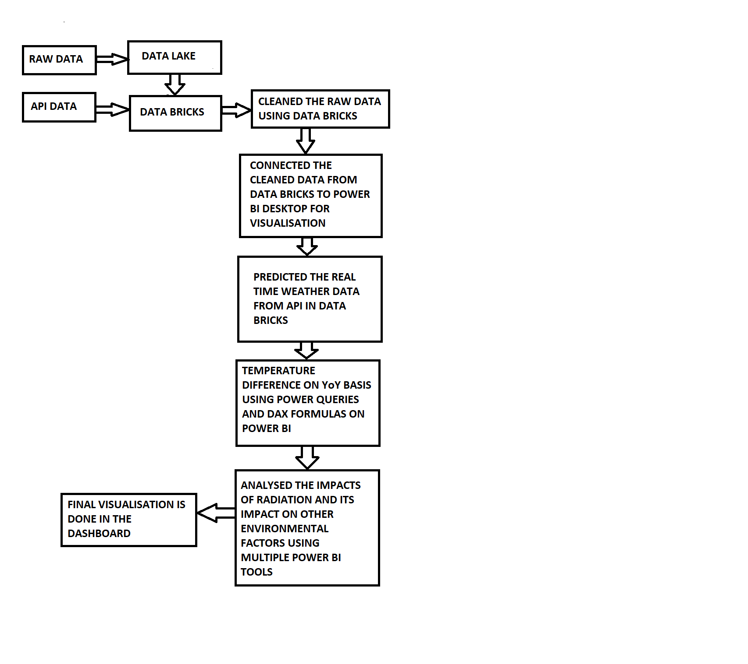

**LIMITATION AND CHALLENGES:**

1. Working virtually was one of the most common issues as we took time to connect and understand each other's point of view.
2. Working on a cloud platform came with its own challenges as we were unable to get the subscription required for Azure platform to work on our project.
3. Collecting the data set was strenuous as we wanted certain fixed categories of data.
4. Confusion on which technology to work with also became a challenge to overcome as we were taught a couple of tools and languages.
5. While working with the weather prediction we encountered certain challenges with auto refreshing.

**FUTURE SCOPE:**

1. Weather forecast to provide near real time natural calamities warnings.
2. Making a ML developed model for real time weather forecast for next 15 days.
3. Analysed data can be used to take measures with respect to protection of the environment.
4. Visualised data can be used for taking precautions against radiation.
5. Real time visualization of climate.

**CONCLUSION:**

The purpose of this project was to predict, identify, analyse and visualize climatic differences with respect to India. Based on the problem statement analysis we can conclude that over the span of 2 decades there have been a few drastic changes in our environment and we have been under the after effects of these changes. These changes had affected certain other climatic factors such as humidity, precipitation, pressure etc.

With the help of this analysis we can also predict various other elements as well and this analysis is proved to be of value in its visualization aspect.

To summarize the above statement, No human activity or practice is totally devoid of associated risks. Radiation should be viewed from the perspective that the benefit from it to mankind is less harmful than from many other agents.

**OUTPUT AND SCREENSHOTS**

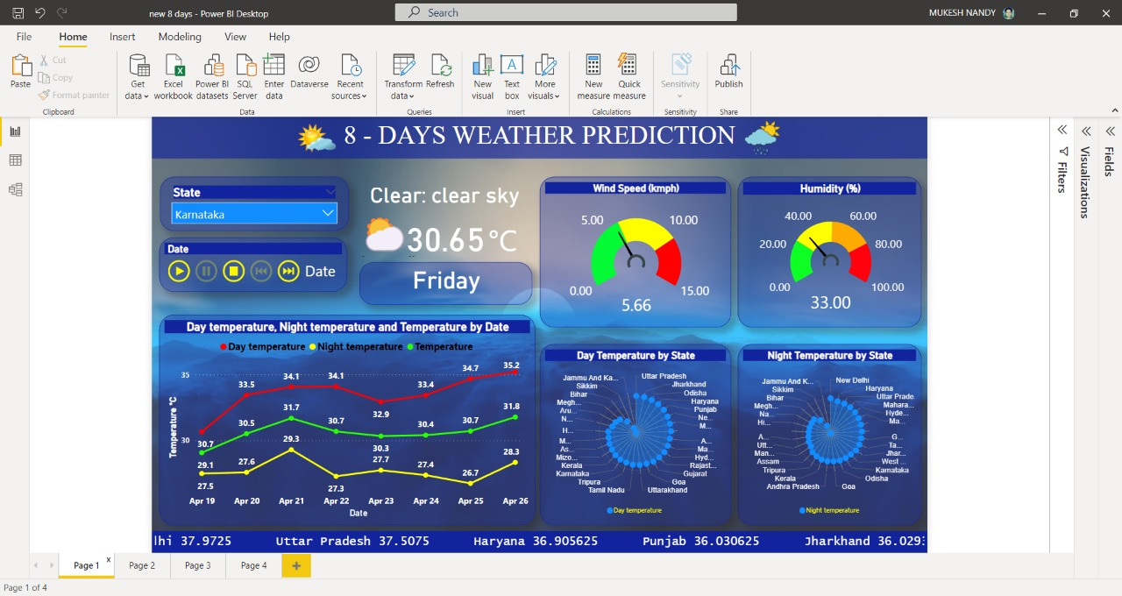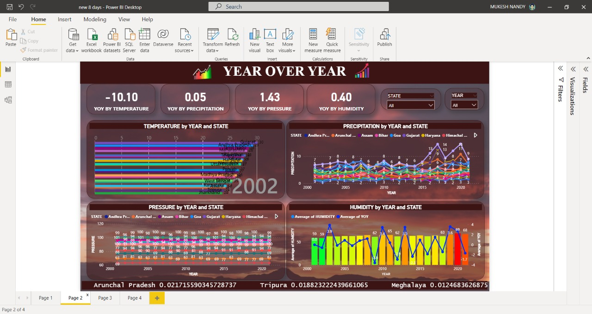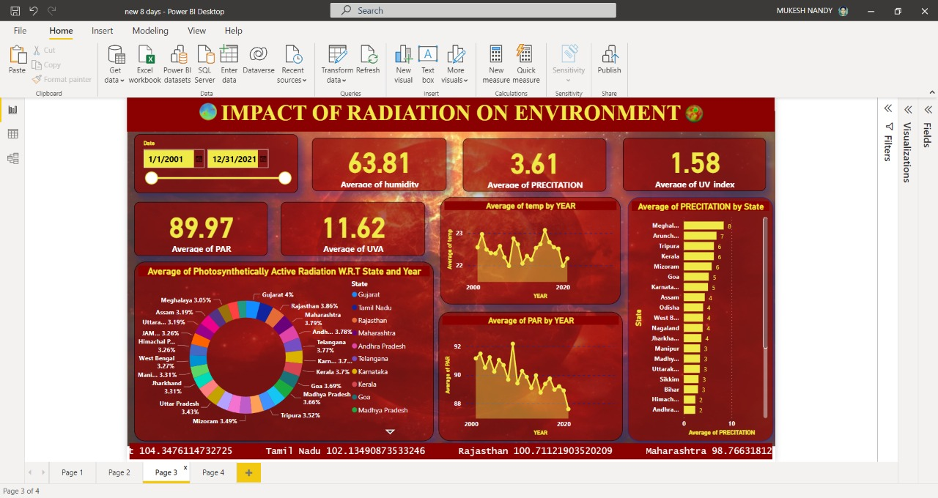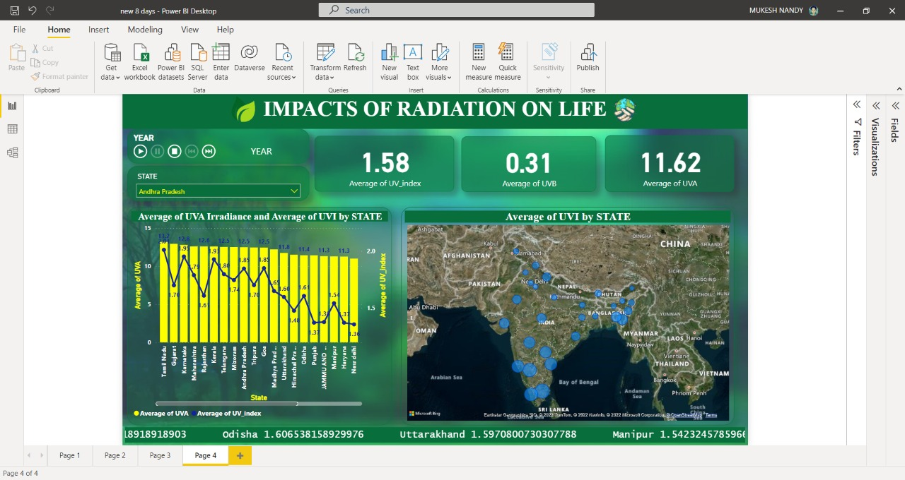

**REFERENCES**

Dataset:

<https://power.larc.nasa.gov/data-access-viewer/>

Code:

<https://ncar.github.io/PySpark4Climate/tutorials/statistical-techniques/mean/>

<https://github.com/visualcrossing/WeatherApi/blob/master/python_samples/loading_weather_data_into_python_timeline.py>

<https://github.com/visualcrossing/WeatherApi/blob/master/python_samples/FetchWeatherHistory.py>

<https://gist.github.com/sposterkil/8fcbd9d87d848b9666d7dacaa5573f4d>

Article:

<https://medium.com/analytics-vidhya/how-to-import-weather-data-into-python-scripts-7e9ff54f6aca>

Video References:

<https://youtu.be/3tbuFJwTEQA>

<https://youtu.be/7StOcESec2c>

<https://youtu.be/UPddzZnsf5w>

<https://youtu.be/7MhjALU0OSc>

<https://youtu.be/UnCi0XUYDOc>

<https://youtu.be/pT0LU9e822c>

<https://youtu.be/3tbuFJwTEQA>

<https://youtu.be/UPddzZnsf5w>

<https://youtu.be/7MhjALU0OSc>